**Order processing:**

Purchase order = alt +f4

Receipt note = alt + f9

Purchase invoice = f9

Sales order = alt +f5

Delivery note = alt +f8

Sales invoice = f8

Purchase return = alt +f6

Or rejection outward

Sales return = ctrl +f6

Or rejection inward

Question : Xerox

Answer:

Step 1: company creation ( accounts with inventory)

Step 2:f11 🡪 inventory features

Purchase order processing: yes

Sales order processing :yes

Use tracking number(delivary / receipt note) :yes

Use rejection inward/outward : yes

Accept: yes

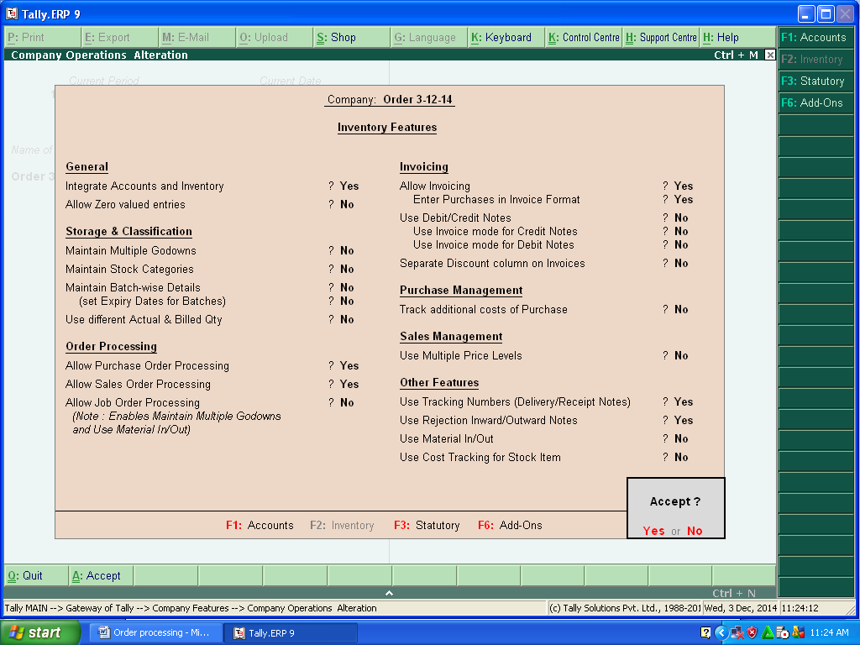

Step 3: ledger (purchase,sara (sc),sales,ragul(sd))

Step 4: inventor info

Stock groups,unit of measue,stock item creation

Step 5: accounting voucher

Alt+f4,alt+f9,f9

Alt+f5,alt+f8,f8

...................................................................................................... Alt+f6

Ctrl+f6

Step 6:

Display: statement of inventory

🡪 sales order outstanding

* Purchase order outstanding
* Reorder status

**ORDER PROCESSING**

It is the process by which a trader purchase/ sale goods from/ to any party.

There are two types of order processing:-

**1)**   **Purchase Order Processing**: - This process is used to purchase goods. It consists following facts:-

           a)    Purchase Order (Alt + F4)

           b)    Receipt Note (Alt + F9)

           c)     Rejection Out (Alt + F6)

           d)    Purchase (F9)

**2)**   **Sales Order Processing**: - This process is used to sale goods to any party. It consists following facts:-

            a)    Sales Order (Alt + F5)

            b)    Delivery Note (Alt + F8)

            c)     Rejection In (Ctrl + F6)

            d)    Sales (F8)

**Example**: ( purchase Order)

vishnu company purchased 50 pieces of HCL Computer from ABC Company on 1.4.2014 at Rate Rs.15000 , but received only 40 pieces of Computer. Due to damage, 10 pieces returned to his supplier and finally received only 30 pieces of computer.

Maintain the above transactions.

**Example**: ( sales Order)

shagul company sold 50 pieces of HCL Computer to mani&c0 Company on 1.4.2016 at Rate Rs.15000 , but send only 40 pieces of Computer. Due to damage, 10 pieces returned from his receiver and finally send only 30 pieces of computer.

Maintain the above transactions.

**To maintain**:-

Create a company and then activate purchase and sales order as follow:-

**Path for Purchase and Sales Order Activation**: - G.O.T. (Gateway of Tally)--> Press F11 (Company Features)--> Press F2 (Inventory Features).

[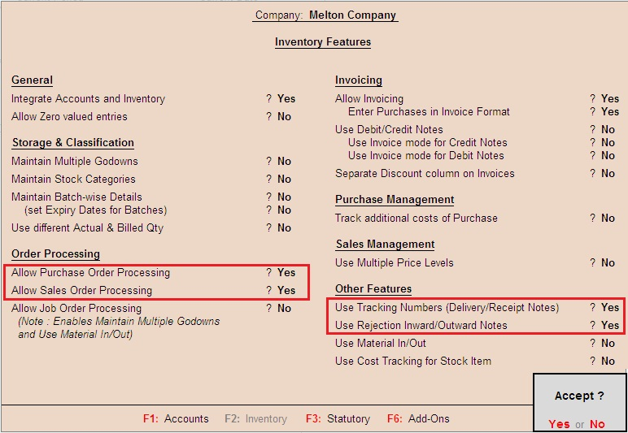](http://1.bp.blogspot.com/-Y56C4BXcduU/VaSj3aNk9rI/AAAAAAAABdk/A1D4XcAayaI/s1600/ACTIVATE+ORDER+PROCESSING.jpg)

After that create stock master:-

**To Create Stock Group**: - G.O.T. (Gateway of Tally)--> Inventory Info--> Stock Group--> Create.

[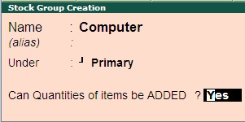](http://1.bp.blogspot.com/-uvXFCc51oUE/VaSj2vkWMnI/AAAAAAAABdg/i1XAsA3JsX8/s1600/COMPUTER+STOCK+GROUP.jpg)

**To Create Stock Item**: - G.O.T. (Gateway of Tally)--> Inventory Info--> Stock Item--> Create.

[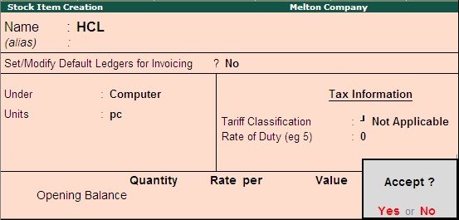](http://3.bp.blogspot.com/-rHeENwM9wS4/VaSj38q4DAI/AAAAAAAABeA/gxsOJqv20S8/s1600/HCL+STOCK+ITEM.jpg)

Now create multiple ledger as follow:-

**Path for ledger creation**: - G.O.T. (Gateway of Tally)--> Accounts Info--> Ledger--> Create (Multiple).

[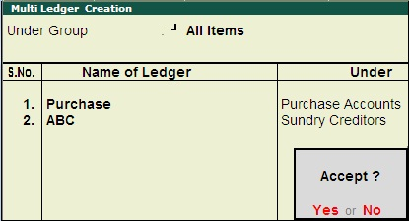](http://4.bp.blogspot.com/-G-L2eLAL_fc/VaSj37uQaoI/AAAAAAAABd8/ZI_p1uASBNA/s1600/MULTIPLE+LEDGERS.jpg)

And then do voucher entry:-

**Path for voucher creation**: - G.O.T. (Gateway of Tally)--> Inventory Voucher--> Press Alt + F4 (Purchase Order).

[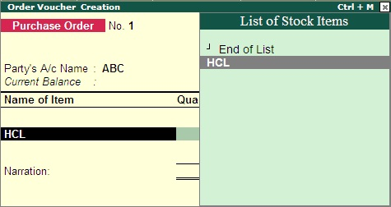](http://1.bp.blogspot.com/-56EAgiTa_VY/VaSj6OAdWgI/AAAAAAAABe8/DvkPwLRpb_M/s1600/PURCHASE+ORDER+1.jpg)

After that, a box will be open, fill it as follow:-

[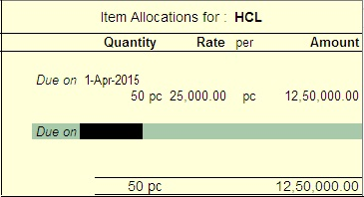](http://3.bp.blogspot.com/-hY71pQXnSgE/VaSj8VNlvJI/AAAAAAAABfo/QhI6NUCdotw/s1600/purchase+order+2.jpg)

And now accept the voucher by pressing “y” or “enter” key.

[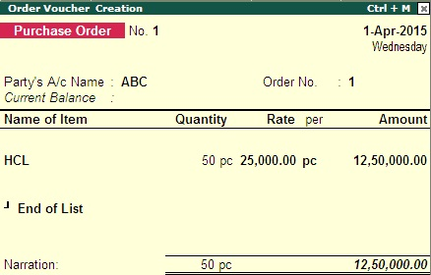](http://1.bp.blogspot.com/-cFKqsl685ew/VaSj892-92I/AAAAAAAABfs/uQ7Ei7ZtBb4/s1600/purchase+order+3.jpg)

Press “Alt + F9” to open Receipt Note.

[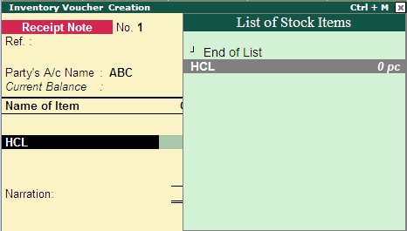](http://2.bp.blogspot.com/-LWI9QzTiRWM/VaSj6copxyI/AAAAAAAABe0/M8KQpE74CKs/s1600/RECEIPT+NOTE+1.jpg)

A box will open after pressing “enter” on HCL, fill it as follow:-

[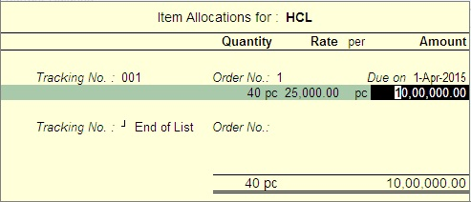](http://3.bp.blogspot.com/-K3imyzifN6o/VaSj6p2-bjI/AAAAAAAABfE/ypdDD4D-Ea0/s1600/RECEIPT+NOTE+2.jpg)

Now accept the voucher by pressing “y” or “enter” key.

[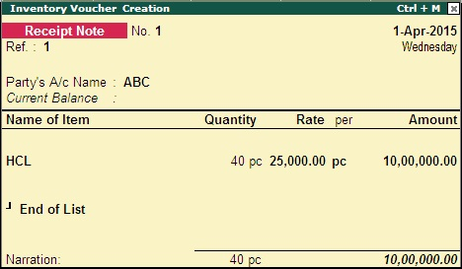](http://3.bp.blogspot.com/-REncuAxKalU/VaSj69K4cUI/AAAAAAAABfI/fC87leliohk/s1600/RECEIPT+NOTE+3.jpg)

Now press “Alt + F6” to open Rejection Out.

[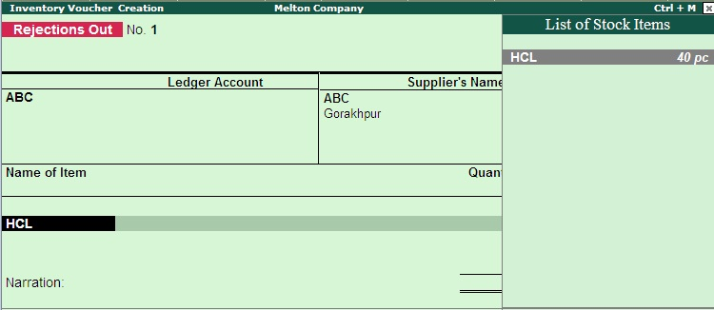](http://4.bp.blogspot.com/-A2x5O6TZkbU/VaSj7YF6cvI/AAAAAAAABfQ/0Rc6sAyKYZE/s1600/REJECTION+OUT+1.jpg)

A box will open after pressing “enter” on HCL, fill it as follow:-

[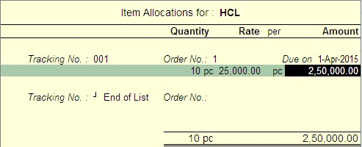](http://3.bp.blogspot.com/-uMlEME-R0m8/VaSj8DcIreI/AAAAAAAABfk/S-KvLEJoHKs/s1600/REJECTION+OUT+2.jpg)

Accept the voucher by pressing “y” or “enter” key.

[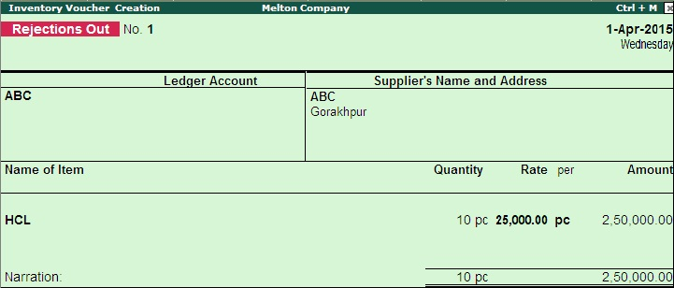](http://4.bp.blogspot.com/-2TCAONDBveE/VaSj8JyKeAI/AAAAAAAABfc/T7PH2mgZMl0/s1600/REJECTION+OUT+3.jpg)

Goods received 40 pieces, rejected 10 pieces so the actual purchase is 30 pieces. Then we will show only 30 pieces in purchase voucher.

Press F9 to open Purchase Voucher.

[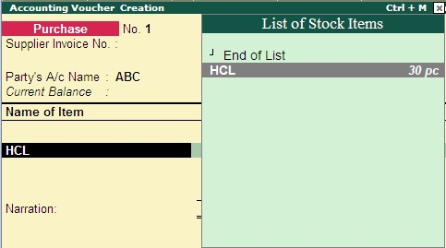](http://3.bp.blogspot.com/-oqqg3s9HwAM/VaSj4VsL8zI/AAAAAAAABeE/CttN9r9j63s/s1600/PURCHASE+1.jpg)

Press “enter” on HCL and fill the form as follow:-

[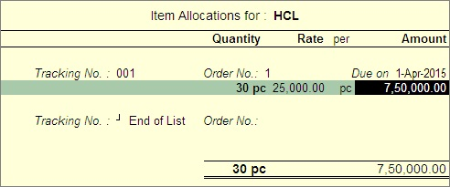](http://1.bp.blogspot.com/-sVybDNDr9mw/VaSj46agnqI/AAAAAAAABeU/sXEKamr3IN8/s1600/PURCHASE+2.jpg)

Press “enter” on “End of List” and again press “enter” more times.

[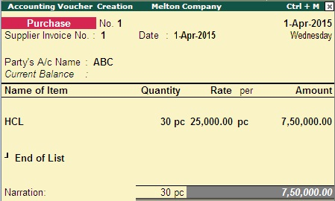](http://1.bp.blogspot.com/-90uQUFaVYUw/VaSj5BdPzgI/AAAAAAAABeY/tERSUN4KXys/s1600/PURCHASE+3.jpg)

Bill Wise Detail form will open, fill it as follow:-

[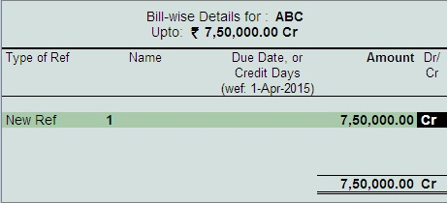](http://1.bp.blogspot.com/-N681Ptu82QU/VaSj5RYaMPI/AAAAAAAABeg/bEik4pzMGUo/s1600/PURCHASE+4.jpg)

Accept the voucher by pressing “y” or “enter” key.

[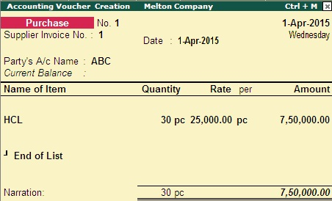](http://1.bp.blogspot.com/-yMb6fW4b2Co/VaSj56qPIXI/AAAAAAAABeo/Mkdx-BGn_vA/s1600/PURCHASE+5.jpg)

Now you can see purchase order outstanding:-

**Path for view Purchase Order Outstanding**: - G.O.T. (Gateway of Tally)--> Display--> Statement of Inventory--> Purchase Order Outstanding--> Stock Item--> HCL.

[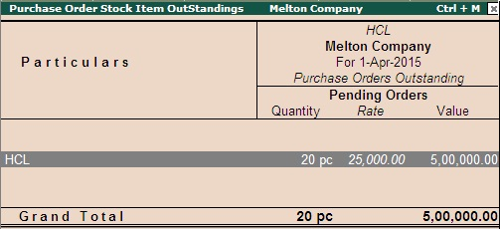](http://2.bp.blogspot.com/-bE-nnWvabJw/VaSj2-8-RXI/AAAAAAAABdo/9llTCutsHUs/s1600/DISPLAY.jpg)

Press “Alt + F1” for more details.